# Programmable Embedded Systems (EE60098)

# Homework 3

Pratyush Jaiswal

18EE35014

## **Q. To enlist and specify all sensors in a smart phone and also find all available sensor attachments which can be interfaced easily in the smart phone**

## **Example of extra sensors: Bring out at least 10 different sensors other than the ones on your phone with sensing technology, Signal to Noise Ratio and possible interface details with the main processor.**

Ans:

**Sensors** is the device which is used in smartphones to detect various aspects of environment. They sense data for which they are made and works according to that. There are various sensors which are available nowadays in smartphones which is in-built and helps in functioning of the smartphone. Basically, they work for better user experience.

**Sensors on a typical Smart Phone**

* **Compass Sensor**

Extremely common and acts as its name, like a compass.

* **Accelerometer Sensor**  
  It is most important sensor which should be available in every smartphone. It helps phone to check its orientation.  
  For Example, if we rotate our phone in landscape mode, then all icons present on screen also moves to landscape mode, and when we want we can change it into portrait mode, this is because of these sensors.
* **Motion sensors**

Motion sensors are used to monitor device movement such as tilt, shake, rotations, flip etc. Typically implemented through an accelerometer.

* **Position Sensors**

Android smartphones provide sensors that let you determine the position of the device geomagnetic field sensor with the help of the accelerometer.

* **Proximity Sensor**

On the top of the screen, it throws out infrared light continuously and detects an object through the reflections. For example, while answering the phone, as you put the phone on your ear, the screen switches off, saving battery as well as preventing accidental touches.

* **Ambient Light Sensor**

Helps in automatically controlling the brightness of the mobile screen. For example if you are in a dark space, then the brightness of the screen decreases, and if you move out into the light, the brightness of the screen would decrease. Can also tune its sensitivity to our comfort.

**Sensors other than the ones present on your phone with sensing technology**

[***Ultra-portable, wireless smartphone spectrometer for rapid, non-destructive testing of fruit ripeness***](https://www.nature.com/articles/srep32504)

This is a smartphone based spectrometer design that is standalone and supported on a wireless platform. The device is inherently low-cost and the power consumption is minimal making it portable to carry out a range of studies in the field. All essential components of the device like the light source, spectrometer, filters, microcontroller and wireless circuits have been assembled in a housing of dimensions 88 mm × 37 mm × 22 mm and the entire device weighs 48 g. The resolution of the spectrometer is 15 nm, delivering accurate and repeatable measurements.

The device has a dedicated app interface on the smartphone to communicate, receive, plot and analyze spectral data. The performance of the smartphone spectrometer is comparable to existing bench-top spectrometers in terms of stability and wavelength resolution.

The device is equipped with a software app that interfaces, collects, stores and analyzes data. It is low power and compatible with a range of analog to digital (A/D) converters and smartphones. We present a complete demonstration of a research grade device that can be used for accurate measurements in the lab and field.

[***Sensirion Multi-Pixel Gas Sensor SGP***](https://www.uradmonitor.com/the-worlds-first-mobile-phone-with-air-quality-sensors/)

The S61 has a built-in gas sensor manufactured by Sensirion, that detects air quality by measuring volatile organic compounds (VOC). Common sources of VOC’s include paints, solvents, carpets, furniture and cleaning products, all common in the environments typical to Cat phone users. If the contaminants concentration exceeds the health limit, the mobile phone will issue a warning reminding the user to open the window for ventilation or go out for a while. The sensor can also provide humidity and current temperature readings.  
[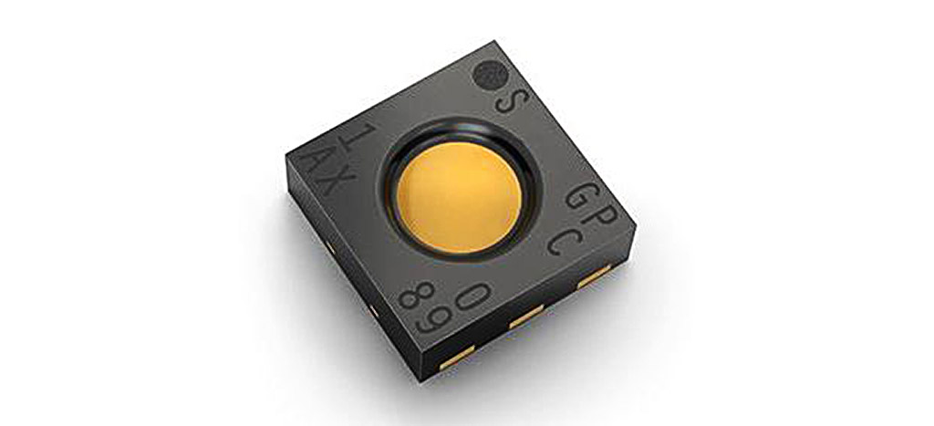](https://www.uradmonitor.com/wordpress/wp-content/uploads/2018/03/sensirion_SGPC10.jpg)

Sensirion SGPC10 sensor

The Sensirion multi-pixel gas sensor platform SGP creates new possibilities for the measurement of indoor air quality. The SGP offers a complete gas sensor system integrated into a very small package featuring an I2C interface and fully calibrated air quality output signals with unique long-term stability and accuracy. The SGP further combines multiple metal-oxide sensing elements − the pixels – on one chip to provide more detailed air quality signals. The unprecedented combination of long-term stability and multi-pixel technology makes the SGP a perfect choice for indoor air quality monitoring in mobile, smart home and appliance applications.  
[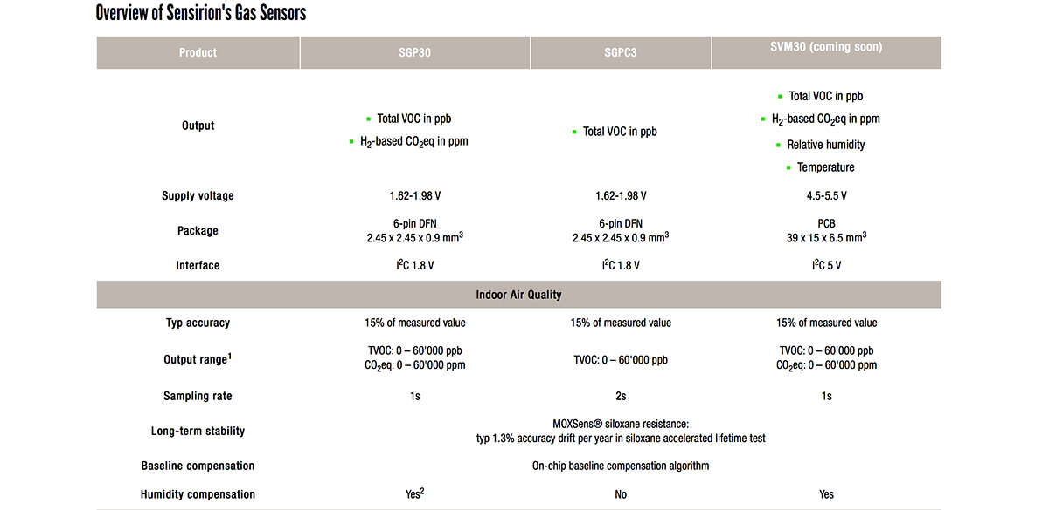](https://www.uradmonitor.com/wordpress/wp-content/uploads/2018/03/sensirion_VOC_sensors.jpg)

Sensirion VOC sensors and specs

Notes:  
\*1 CO2eq output is based on a hydrogen measurement. The SGP is not suited for applications where real CO2 detection is required.  
\*2 To use the humidity compensation feature of the SGP30 an additional humidity sensor like the SHTxx is required.  
There are [certain limitations](https://www.uradmonitor.com/metal-oxide-voc-sensors/) in using this technology to measure air quality or to determine absolute concentration readings for various substances in the air. Read [more here](https://www.uradmonitor.com/metal-oxide-voc-sensors/).

**Specs and price range**

* Rugged phone, IP68 certified (dust/water proof over 3 meters and 60 minutes), Drop-to-concrete resistance up to 1.8 m, MIL-STD-810G compliant, 5.2inch display Corning Gorilla Glass 5.
* It runs Android 8.0, on a Qualcomm SDM630 Snapdragon 630 chipset holding a Octa-core 2.2 GHz Cortex-A53 CPU. There’s an external micro-SD slot.
* The main camera is 16 MP, with phase detection autofocus and dual-LED dual-tone flash.
* It supports GLONASS for enhanced positioning capabilities and also has an FM Tuner for Radio. The battery is 4500mAh and it is non removable.

[***Brain Sensing Headband, Muse S***](https://choosemuse.com/muse-s/?sscid=81k5_ujs0x&utm_source=ShareASale&utm_medium=Affiliate&utm_campaign=1480782&utm_term=635671)

Using advanced EEG technology to respond to your mind, heart, and breath, the Muse S is a comfy brain sensing headband that helps you understand and track how well you focus, sleep and recharge so you can refocus during the day and recover each night.

**Spec**

Sleep (EEG + PPG + Accelerometer)

Mind (EEG)

Heart (PPG + Pulse Oximetry)

Body (Accelerometer)

Breath (PPG + Gyroscope)

10 Hours of Battery Life (Rechargeable Li-Ion)

1 Headband, Multiple Users

Wireless Connection: BT 4.2

MicroUSB port (cable included) and LED Indicator

Muse App Compatibility (iOS 11, Android 5 or higher, Huawei devices not supported)

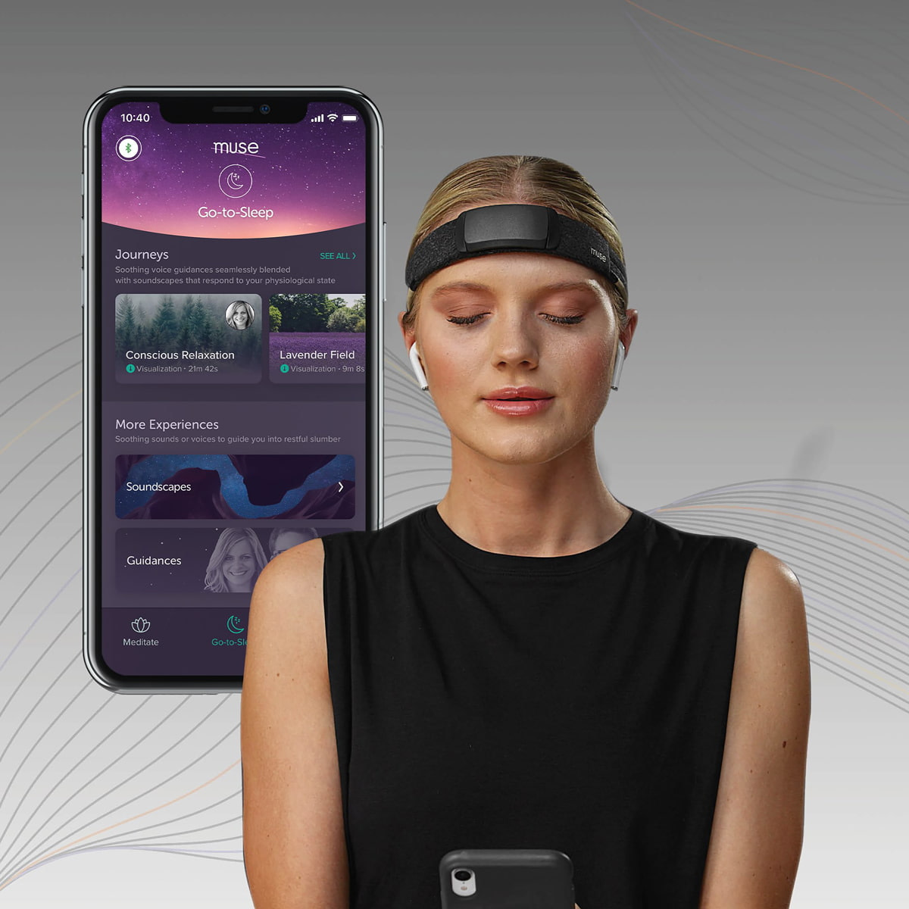

[***3-in-1 Blood Pressure Monitor***](https://www.withings.com/us/en/bpm-core?utm_source=CJ&utm_medium=Affiliate&utm_campaign=affiliation-TRAVEL+AWAY+SC&utm_content=7639031-Home+Page+US-13184200&CJEVENT=02fd41cf08a911ec82d003f10a180514&cjdata=MXxOfDB8WXww)

When it comes to on-the-go blood pressure monitoring, it doesn’t get more stylish than [BPM Core](https://www.anrdoezrs.net/click-7639031-13184200?url=https%3A%2F%2Fwww.withings.com%2Fus%2Fen%2Fbpm-core). Combining elegant, minimalist design with innovative technology, the compact 3-in-1 health gadget is also able to record a medical-grade ECG, as well as to detect valvular heart disease by virtue of its integrated digital stethoscope.

Readings are instantly shown on the device, but the dedicated Health Mate app gives you instant color-coded feedback and professional recommendations, and makes it easy to keep track of your measurements.

**Developed for health & backed by science**

BPM Core has been developed with the help of cardiologists from two major hospitals in Paris.

##### **Blood Pressure | Prevent hypertension**

BPM Core provides medically accurate results on your systolic and diastolic blood pressure. Taking your blood pressure at home with BPM Core can also help avoid white-coat syndrome, detect masked hypertension, and manage nocturnal hypertension. After each measurement, you’ll see easy-to-read color-coded feedback based on the American Heart Association recommendations for hypertension.

**Electrocardiogram | Detect atrial fibrillation**

BPM Core records a medical-grade ECG thanks to 3 electrodes: 2 in the cuff and another in the steel tube held during the measurement. The data is shown live on the device and sent to the app, so you’ll see instant feedback if you show signs of atrial fibrillation.

**Data at your fingertips**

BPM Core seamlessly syncs with the free Health Mate app. You can access your data in the app or on the web with your personal Withings account. See your progress, share your data, and more.

***[Wireless Smart Glucometer](https://www.amazon.com/iHealth-Wireless-Glucometer-Bluetooth-Monitoring/dp/B00N1IRZTW/ref=as_li_ss_tl?th=1&linkCode=sl1&tag=travgadg-20&linkId=0cb446e9f1760ca7d318ea31fd070341&language=en_US)***

Made by iHealth Lab Inc, the [Wireless Smart Gluco-Monitoring System](https://amzn.to/2Opqzfu) is a state-of-the-art, FDA-approved glucometer that measures glucose levels in the blood and then displays them on your smartphone.

This innovative health gadget features a sleek, portable design and is compatible with Apple devices. The accompanying iHealth Smart-Gluco app allows you to keep a history of all your measurements and share them with your doctor.

In addition to the glucometer itself, the kit includes 10 testing strips, 10 lancets, control solution, a lancing device, and a carry bag.

**iHealth Wireless Gluco-Monitoring System -Only 25 cents per test strip**

Track your blood sugar levels with or without a smartphone. The iHealth Gluco glucose meter, designed for diabetic patients, measures blood sugar levels. The results are displayed directly on the screen or on the iHealth Gluco-Smart app. Track your results and consult your history whenever you need to. iHealth Gluco is an in vitro diagnostic medical device.

**The advantages**

Control the glucose level in your blood with or without smartphone. Connected in Bluetooth to your smartphone, iHealth Gluco is for the self-monitoring of glucose levels for diabetic patients. It allows you to directly know your blood glucose levels so that you can control them and thus prevent imbalances and adapt your treatment. Its carry bag allows you to take it anywhere with you.

• Model: BG5  
• Result Range: 10 mg/dL ~ 600 mg/dL  
• Li-ion 250mAh Battery  
• Wireless communication: Bluetooth 3.0  
• Measuring method: Amperometric technology using glucose oxidase  
• Single patient use for self-testing only  
• Use only iHealth Test Strips

[***Smart Air Quality Monitor***](https://www.amazon.com/Airthings-2930-Quality-Detection-Dashboard/dp/B07JB8QWH6?&linkCode=sl1&tag=travgadg-20&linkId=0c2f49adddaa07691a13a345070e1c30&language=en_US&ref_=as_li_ss_tl)

It may look like a generic smoke detector, but this sleek device is the first indoor air quality monitor with radon detection.

Thanks to its accurate sensors and free mobile app, the [Airthings Wave Plus](https://amzn.to/3mn9siY" \t "_blank)  
alerts you in real-time about the presence of volatile organic compounds (VOCs) and harmful gases like Raden and CO2 while also measuring air temperature, atmospheric pressure, humidity, and even pollen levels, in the environment around you. This data is displayed on your smartphone via the Airthings companion app, which also provides tips to reduce indoor air hazards, optimize ventilation, and save energy.

We spend 90% of our time indoors where the air is often 2 to 5 times worse than the air outside. Continuous monitoring of indoor air quality is key for minimizing negative health effects, preventing illness and increasing productivity, energy and good health. Airthings, air quality specialists and experts in radon, created the Airthings Wave Plus as the first smart air quality monitor with radon detection. Wave Plus has since won multiple awards for consumer electronics and innovation and was among the 2019 TIME Magazine inventions of the year. It is the perfect solution for homeowners to gain full visibility into six indoor air factors; radon, carbon dioxide (CO2), airborne chemicals (TVOCs), humidity, temperature and air pressure. Airthings Wave Plus includes a free app to connect to your smartphone (iOS/Android) via Bluetooth and an online dashboard with advanced analytics. Battery operated allowing you to install anywhere, with 16 months battery life. Please allow for a 7-Day settling period for the sensors to adjust to their new environment. By monitoring daily and continuously, you can avoid radon side effects, get the best indoor humidity level, low voc levels and low carbon dioxide levels. Made to the best indoor air quality standards, Airthings Wave Plus is essential in every home.

[***Smart Temporal Thermometer***](https://www.withings.com/us/en/thermo?utm_source=CJ&utm_medium=Affiliate&utm_campaign=affiliation-TRAVEL+AWAY+SC&utm_content=7639031-Home+Page+US-13184200&CJEVENT=3a698b0a08ab11ec81575d6d0a180513&cjdata=MXxOfDB8WXww)

***Thermo*** is a game changer. Now, a fast, simple, no-contact gesture yields medical-grade results right on the device and provides an automatic sync with the free Thermo app, available for iOS and Android. In the app, you can track temperature readings, set reminders, and input related symptoms & medications for advice right on your smartphone.

**Highly accurate**

Thermo measures from the temporal artery, considered an ideal place to detect temperature changes, as the blood that circulates there comes from the core of the body.

16 infrared sensors take over 4,000 measurements—a revolutionary advancement, and what we call HotSpot Sensor Technology.

**No contact with skin required**

Enjoy a contactless scan up to 1 cm from the forehead. Unlike other thermometers, Thermo does not need to come into contact with any body fluids, such as saliva, perspiration, or earwax. It is the most hygienic way to take anyone's temperature, as Thermo does not need to be cleaned between each measurement.

**Instant feedback**

Readings appear illuminated on the device along with a color-coded LED indicator to tell you if the temperature is normal, elevated or high based on the age of the user.

**Know when it's time to take action**

Measurements sync automatically with your smartphone. Based on age, fever history, and symptoms, the Thermo app gives advanced health advice. And Boston Children’s Hospital provides Thermia, educational information on proper medications and dosages.

**Connectivity**

* App
  + Withings Health Mate is the best way to keep track of activity, sleep, weight, and more.
* Wireless Sync
  + Bluetooth Smart Ready
  + Wi-Fi b/g/n 2.4 Ghz (WEP, WPA, WPA2-personal encryptions)
* Requirements
  + Thermo can be installed on a smartphone or a tablet, via the Health Mate app available on iOS (iOS 10 and higher) and Android (6.0 and higher).
  + Cannot be set up from a computer

**Device**

* Sensor
  + Thermopile array sensor (infrared sensors)
* Display
  + 20x5 LEDs matrix display
  + Button and touch sensitive slider
* Dimensions and weight
  + Length: 116 mm (4.57 in.)
  + Diameter: 33.2 mm (1.31 in.)
* Weight: 75g (0.165 lbs), including batteries weight
* Power supply
  + 2x 1.5V LR03 AAA alkaline cells

**Metrics tracked**

* Metrics
  + Clinical accuracy: ±0.2°C (±0.4°F) | Display of rectal equivalent temperature
  + Temperature range: 35°C - 43.2°C (95°F - 109.8°F)
  + Resolution: 0.1°C / 0.1°F

[***Fertility Tracking Bracelet, Ava***](https://www.avawomen.com/)

The first fertility-tracking wearable on the market, [Ava](https://fave.co/3azGzHx) uses physiological parameters like temperature, resting pulse rate, and breathing rate to detect a woman’s fertile window. All you have to do is wear the intelligent FDA-approved bracelet on your wrist while sleeping and then sync it up with the companion app in the morning to see which are your five best days to try for a baby.

**How Ava works:**

1. WEAR AVA TO BED

Overnight, the Ava sensor bracelet collects continuous data while you sleep.

2. WAKE UP AND SYNC

In the morning, sync your bracelet to the app, and Ava’s algorithm instantly shows your results.

3. SEE YOUR MOST FERTILE DAYS

Ava pinpoints your five best days to try for a baby as they're taking place.

Ava’s sensor bracelet collects data 25 times per second while you sleep. This information is then analyzed to pinpoint your fertile window in real-time using a combination of multiple algorithms.

[***Flow by Plume Labs Air Pollution Monitor***](https://plumelabs.com/en/flow/)

Flow 2 is the next generation of Plume Labs award-winning personal air quality monitor.

Measure air quality, predict pollution and plan your commutes with your personal air quality sensor and companion app.

LEDs give immediate feedback while the app explains what’s in your air.

Flow is an ever-improving coach for healthier routines and better air quality choices.